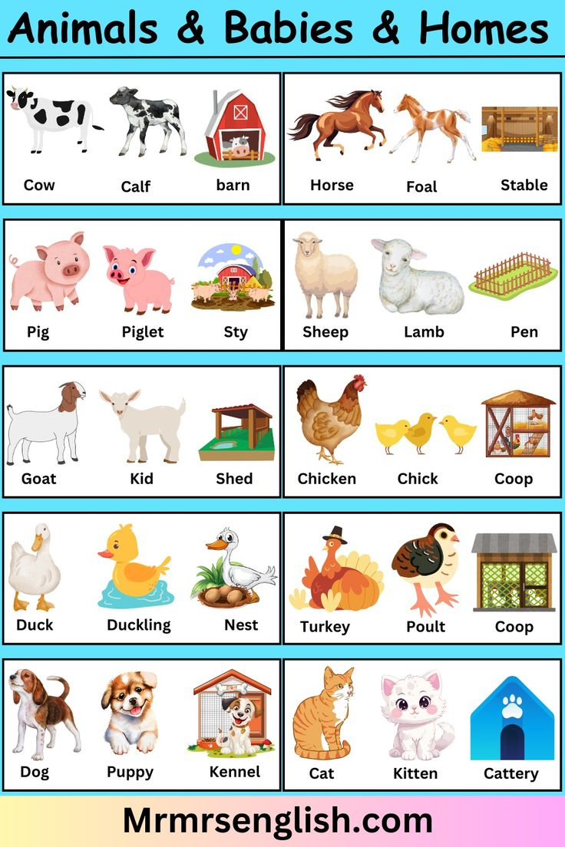
CHICKEN AND ITS YOUNG ONE IMAGE

